**Assignment**: (Restfull APi) - Assignment ID: 11_RestFulAPI_Assignment1

Develop Spring Web Application Which Provides a set of restful web services that can facilitate the below operations a. POST a Book (create a new book record)

b. PUT a book (existing to modify)

c. DELETE a Book

d. GET a book By id

e. GET all books

**Code**:



**Web Page Screenshots (Angular and Spring Boot - Spring Data)**:

**GET by Book ID**

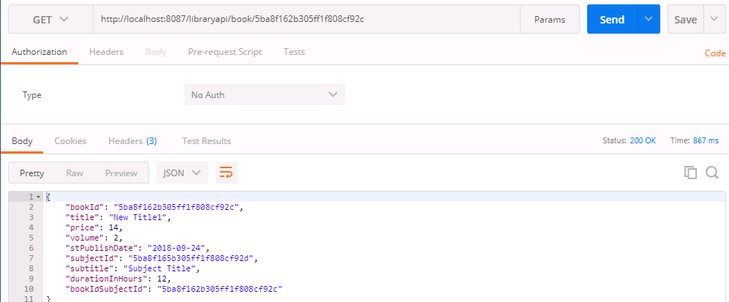

**GET All**

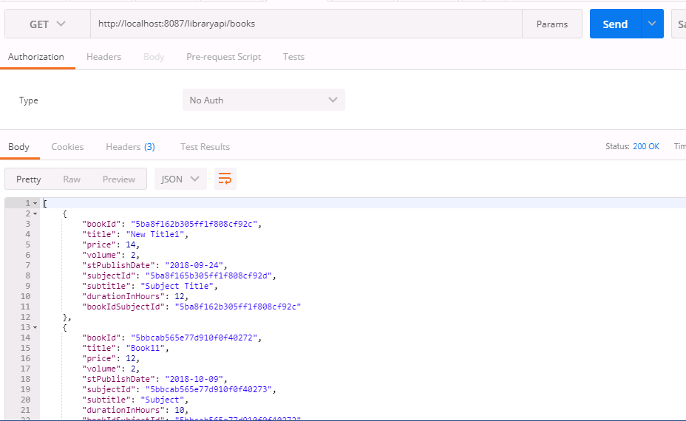

**POST**

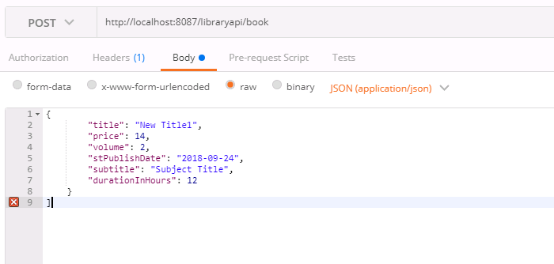

**PUT**

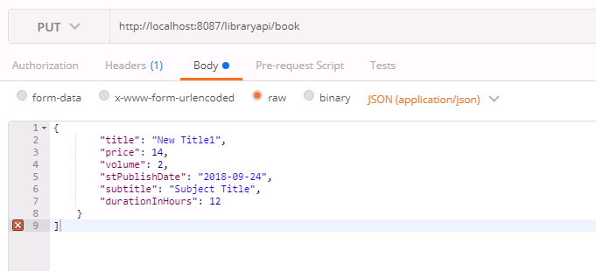

**DELETE**

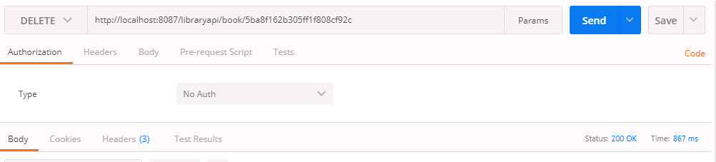

**Subject Book List**

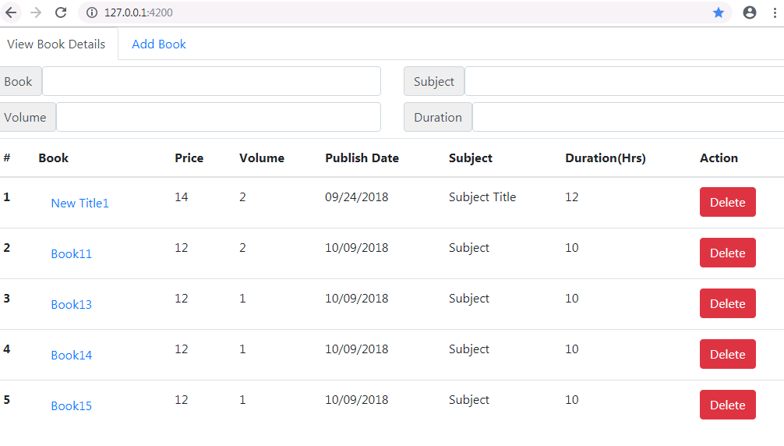

**Subject Book Add Page**

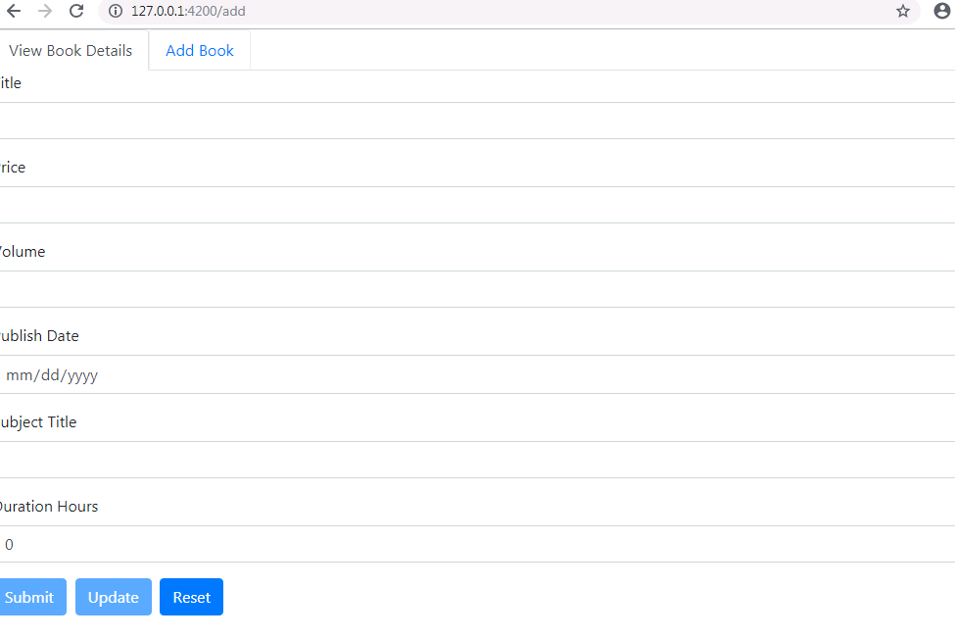

**Search using Book**

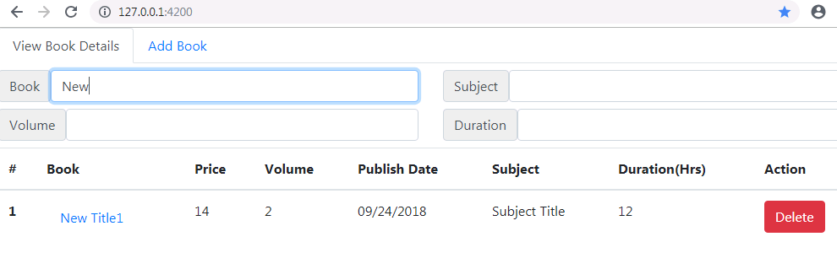

**Search using Subject**

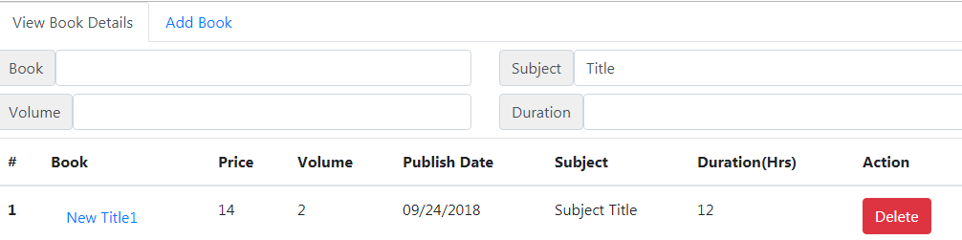

**Search using Volume**

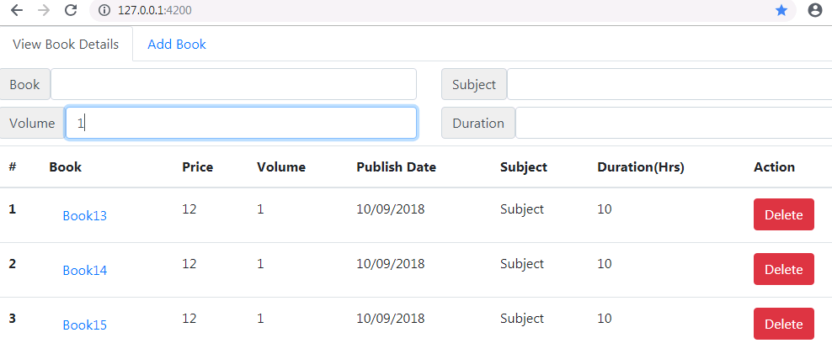

**Mongo DB Command prompt**

